The post-experiment survey for each experiment is available as part of the OSF repository (see experiments/experiment-NAME/surveys/) The post-experiment survey for

* **Norming experiment 1A** was identical to that of Liu and Jaeger (2018). Questions assessed the quality of the audio equipment, whether participants experienced stalling of audio or video (to help us catch problems with our code). Of particular note, the survey also contained a catch question, asking about the gender of the talker shown during the test phase. Following this survey, a final exit survey collected demographic information using the gender, age, race, and ethnicity categories required for NIH reporting. All responses in the demographic survey were indicated as optional.
* **For Norming experiment 1B** we changed the post-experiment survey in three ways. First, we removed one question about audio quality which asked participants to rate the quality of their audio equipment as "good, professional, bad etc.". The subjective nature of this question made it hard to interpret. Second, in order to encourage the participants to answer survey questions truthfully, we emphasised that they would get compensated independent of their answers, and that truthful answers would greatly help us with the interpretation of results. Third and finally, we added three questions that assessed the smoking habits of the participant, the exposure to smoking while growing up, and the exposure to smoking in the everyday life of the participant. These questions were included because some of the experimenters had independent interests in whether extended exposure to audiovisual speech inputs by talkers with pen-like objects in their mouth would affect how listeners perceived "asi" and "ashi" productions by a talker with a pen in the mouth.
* **For Norming experiment 1C and 1D,** we added an additional question to the post-experiment survey. This question asked the participants to select their current timezone to let us know in what part of the US they were located and at what time of the day they took the HIT. There are also wording changes (all updates marked with highlights).

**GREEN HIGHLIGHT → updated wording / added question**

**RED HIGHLIGHT → question deleted in the next norming experiment**

### 

### 

### **NORM 1A**

1. Did any of the **audio clips** stall or lag during the experiment?

* Yes, many
* Yes, just a few
* No, none

1. What kind of audio equipment did you use for the experiment?

* In-ear headphones
* Over-the-ear headphones
* External Speakers
* Laptop Speakers

1. How does your audio equipment sound when you have Skype conversations, watch (high quality) music videos on YouTube, watch movies on Netflix, or engage in other similar activities involving audio?

* Poor (most words cannot be understood)
* Okay (many sounds are distorted)
* Good (occasionally some minor distorted sounds)
* Excellent (crystal clear with no distorted sounds)
* Professional quality
* I don't know or don't do any of the above.

1. Did you notice anything odd about the speaker in the video?

* **\*text-box for subjects to answer\***

Check any boxes that you think describe the speaker in the video.

* Slower than normal speaking rate
* Normal speaking rate
* Faster than normal speaking rate
* Higher than normal voice pitch
* Lower than normal voice pitch
* Standard accented English
* Accented or unusual pronunciations
* Relaxed
* Serious

1. Was the speaker in the video a man or a woman?

* Man
* Woman

1. Did you notice anything in particular about how the speaker in the video said words that contained an "S" or "SH" sound?

* Yes
* No

1. Which of the following best describes how the speaker in the video produced the "S" and "SH" sounds?

* Both S and SH sounded normal.
* S sounded like SH.
* SH sounded like S.
* S sounded like SH and SH sounded like S.

1. You can enter any other comments you have below.

* **\*text-box for subjects to answer\***

**NORM 1B**

### **“Please answer the questions on this survey truthfully. Your answers will not affect your compensation.”**

1. Did any of the **videos** stall or lag during the experiment?

* Yes, many
* Yes, just a few
* No, none

1. Did any of the **audio** clips stall or lag during the experiment?

* Yes, many
* Yes, just a few
* No, none

1. What kind of **audio equipment** did you use for the experiment?

* In-ear headphones
* Over-the-ear headphones
* External Speakers
* Laptop Speakers

1. Did you notice anything odd about the person in the video?

* **\*text-box for subjects to answer\***

Check any boxes that you think describe the speaker in the video.

* Slower than normal speaking rate
* Normal speaking rate
* Faster than normal speaking rate
* Higher than normal voice pitch
* Lower than normal voice pitch
* Standard accented English
* Accented or unusual pronunciations
* Relaxed
* Serious

Was the speaker in the video a man or a woman?

* Man
* Woman

1. Did you notice anything in particular about how the speaker in the video said words that contained an "S" or "SH" sound?

* Yes
* No

1. Which of the following best describes how the speaker in the video produced the "S" and "SH" sounds?

* Both S and SH sounded normal.
* S sounded like SH.
* SH sounded like S.
* S sounded like SH and SH sounded like S.

1. Which of these best defines your personal smoking habits?

* I don't smoke or I smoke less frequently than one cigarette per day.
* I smoke more than one cigarette per day.
* I smoke more than 10 cigarettes per day.

1. In your current daily life, how often do you interact with people while they are smoking?

* Never or less frequently than once per day.
* More than once per day.
* More than 10 times per day.

1. Which of these best defines the environment in which you were raised?

* No one close to me was a smoker.
* One parent/guardian/person I saw on a daily basis was a smoker.
* Multiple people I saw on a daily basis were smokers.

1. You can enter any other comments you have below.

* **\*text-box for subjects to answer\***

**NORM 1C / FINAL SET OF QUESTIONS (updates to wording + timezone question)**

### **Please answer the questions on this survey truthfully. Your answers will not affect your compensation.**

1. What kind of **audio equipment** did you use for the experiment?

* In-ear headphones
* Over-the-ear headphones
* External Speakers
* Laptop Speakers

1. Did you notice anything odd about the person in the video? (Please note that we will ask about audio/video lag in subsequent questions. Here we are interested in understanding anything you noticed about the person in the video.)

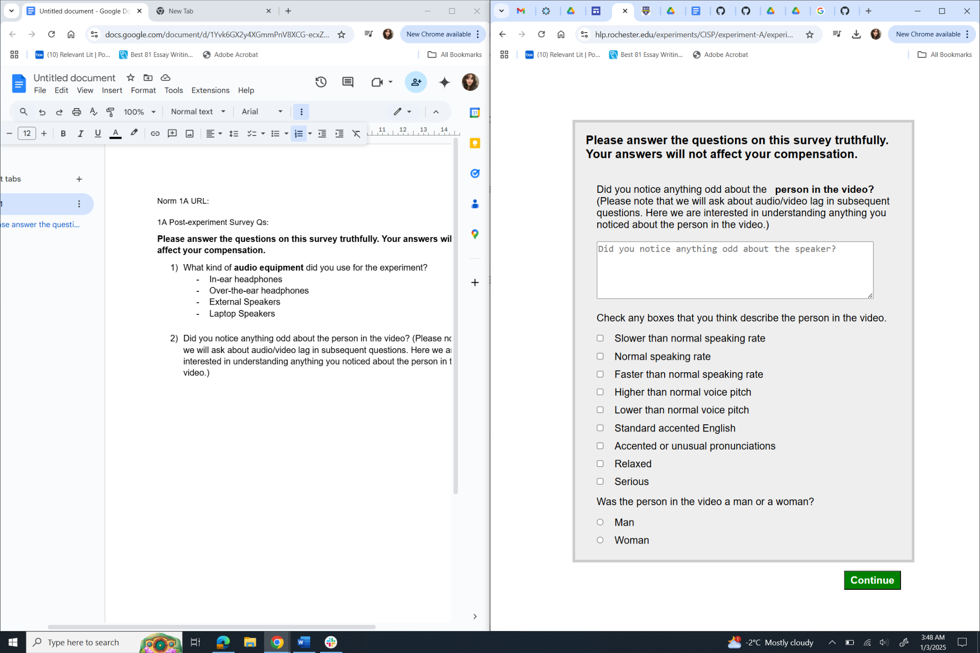

1. Did you notice anything in particular about how the person in the video said words that contained an "S" or "SH" sound?

* Yes
* No

1. Which of the following best describes how the person in the video produced the "S" and "SH" sounds?

* Both S and SH sounded normal.
* S sounded like SH.
* SH sounded like S.
* S sounded like SH and SH sounded like S.

1. The videos and sounds in this experiment were manipulated by aligning the same video with different sound sources. As a consequence, you might have noticed some 'jumps' or slightly odd looking moments in the video. **Here we are interested in potential technical issues with the internet connection beyond any oddities you might have noticed about how the video and sound aligned.** Did any of the **videos** fail to load or stop playing for a moment and then restart during the experiment? (We will ask about the sounds separately on the next page.)

* Yes, many
* Yes, just a few
* No, none

1. Did any of the **audio** clips fail to load or stop playing for a moment and then restart during the experiment?

* Yes, many
* Yes, just a few
* No, none

1. Which of these best defines your personal smoking habits?

* I don't smoke or I smoke less frequently than one cigarette per day.
* I smoke more than one cigarette per day.
* I smoke more than 10 cigarettes per day.

1. In your current daily life, how often do you interact with people while they are smoking?

* Never or less frequently than once per day.
* More than once per day.
* More than 10 times per day.

1. Which of these best defines the environment in which you were raised?

* No one close to me was a smoker.
* One parent/guardian/person I saw on a daily basis was a smoker.
* Multiple people I saw on a daily basis were smokers.

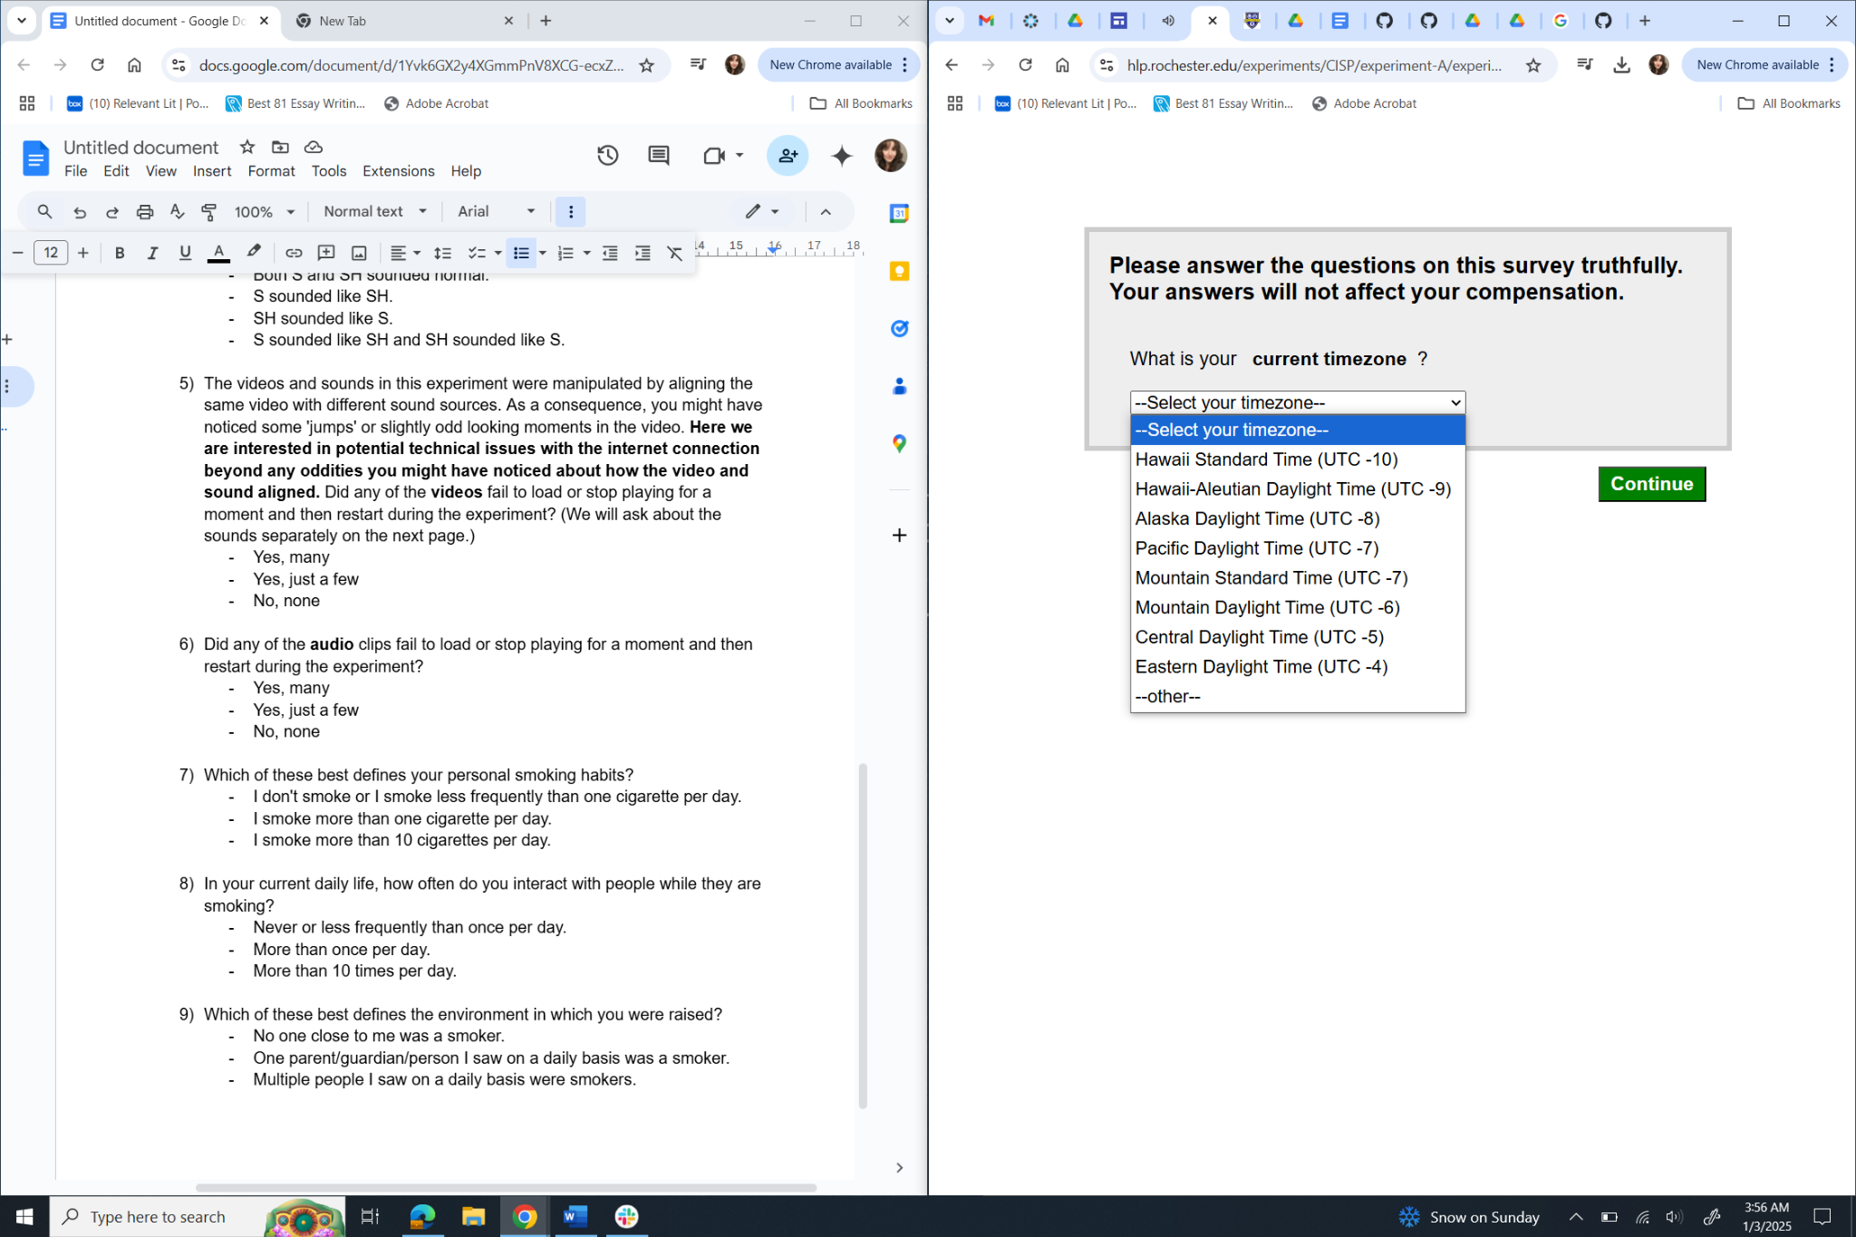

2. You can enter any other comments you have below.

* **\*text-box for subjects to answer\***